DECEMBER 2017
Congratulations to Shellbrook Public Library
For earning one of the 2016 Branch Awards from Wapiti.
Branch awards are given to 2 branches each year that excel in their programming and circulation.
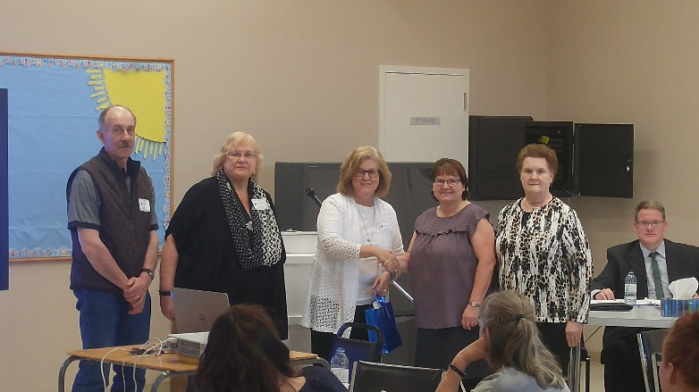

Congratulations and Thank You
To Deb Mervold, who is retiring from the Library Board at the end of this year. Deb has been a board member for 39 years, and Chairperson for 36 of those years. A huge thank you for all the years you have volunteered your time and wisdom to the library. You have helped make this Library into what it is today. Thank You Deb. You will be missed.
Also retiring from the board are Kim Bradley and Melba Souch, who have spent many years as board members. Your years of faithfully commitment have kept our library strong and thriving. Thank You.

**Just a Note: It is volunteers who give their time and enthusiasm into the Library that keeps our Library functioning. How about you?? If you love Libraries and Reading, consider volunteering for our Library Board. For more information contact the Library @ 306-747-3419.

It’s Our Winter Book Sale!!!
It’s that time again. Our Winter Book sale begins on December 4th.
Need a good stocking stuffer – We have paperbacks and DVD’s
Have a relative or friend that loves to read – We have lots to chose from.

ON DISPLAY @ SHELLBROOK PUBLIC LIBRARY
***Stop in and see Paintings and Art by Local Artists. The Saturday Painter’s Group will be displaying their Art for everyone to come enjoy.
The Saturday Painters meet at the Library the first Saturday of each month. 9:30 am -3:30 pm.
Do you like to Paint-Draw-Sketch-Craft? They would love to have you join the group.
For more information call Cathy Atkinson @ 306-747-3634

***We also have on Display a lovely Doll Collection. These dolls are are part of Ida Groenen’s Collection; on loan from the Shellbrook Museum. They are from many different parts of the world. To view the entire collection visit the museum. Contact Marlene @ 306-747-2475

December Programming @ Shellbrook Public Library

Reader’s Theatre
Parkland Integrated Health Center
Friday, December 8th – 2:30pm
Tuesday, December 12 – 2:45pm

Saturday Painters – Saturday December 2nd 9:30am -3:30pm
Adult Book Club –Wednesday, December 13th, 7:30pm
Choose your own books to read, then came and share the Love of reading with others.

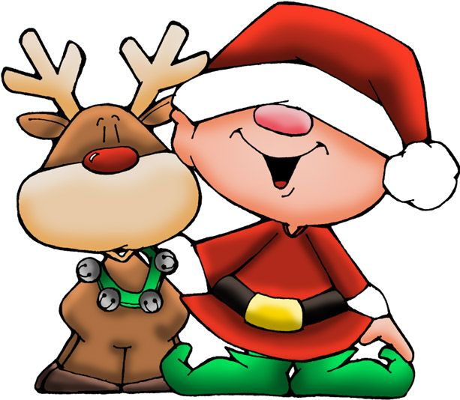
Children’s Programming
Story Time – Fridays at 10:30 am
Stories, Songs, crafts and activities –
For children aged 2 and up
This Month’s Theme – Christmas Creations
(There is No Story Time on December 29th)
*LEGO CLUB*
@ Shellbrook Public Library
Kids Grade 1 to 5 – Come and build with us.
There is no charge.

Monday, December 11th -3:30-5:00pm
This Week’s Challenge; Design and Build a LEGO Ornament
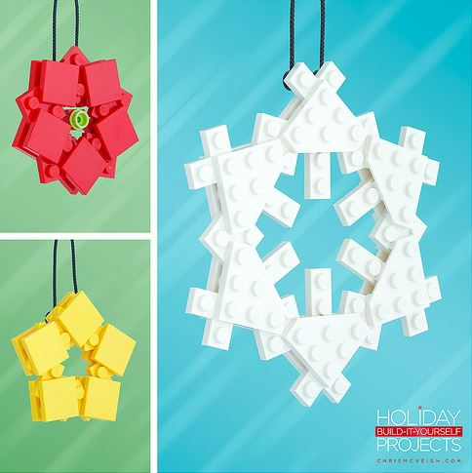
Children finishing the weekly challenge will earn a treat
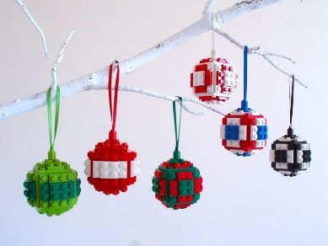

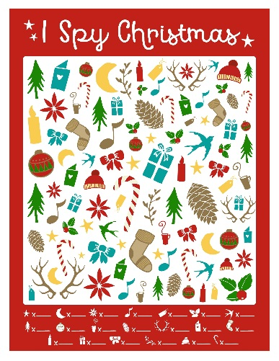

After School Activities: December 2017
I SPY CHRISTMAS!!! Come and solve the puzzles on our
I SPY CHRISTMAS table and win a Sweet Treat

Just a Reminder: the Shellbrook Public Library will be closed for the Holidays
Monday December 25, Tuesday December 26th and Monday January 1st (2018)

DONATIONS TO THE LIBRARY:
Shellbrook Public Library gladly accepts donations for its June/December Book sales.
Books, magazines, videos, games and puzzles.

Lego Club is looking for donations of LEGO for the kids to use. If you have some talk to Dian at the Library. 747-3419

**If you wish to be removed from the Shellbrook Public Library newsletter, please notify the Librarian.

